

**CinaVerse - Movie Watchlist Web Application**

Group Members:

Mamoona (231662)

Maheen Fatima (231659)

Huzaifa Yasir Khan (231617)

**Full Stack Web Development**

**Table of Contents**

1. Introduction 3

2. Problem Statement 3

3. Proposed Solution 3

4. API Integration 4

5. Features & CRUD Operations 4

6. Authentication & Authorization 4

7. Database Requirements 5

8. User Interface & Design Appeal 5

9. Complexity & Technical Stack 5

5. Iteration / Sprint Plan 6

10. Mockup Screens 6

6. Conclusion 16

**Table of Figures**

Figure 1 - signin page 6

Figure 2 - Homepage 7

Figure 3 - Trending page 8

Figure 4 - Movie details page 9

Figure 5 - Additional note option while adding in watchlist 9

Figure 8 - Signup / Signin Page 11

Figure 9 - HomePage(1) 12

Figure 10 - HomePage(2) 13

Figure 11 - MovieStreaming page 13

Figure 12 - DiscoverPage(2) 14

Figure 13 - DiscoverPage (1) 14

Figure 14 - DiscoverPage(2) 15

Figure 15 - Profile Page 15

**Table of Tables**

Table 1 - CRUD Operations 4

1. **Introduction**

In today’s digital entertainment landscape, binge-watchers, students, and casual viewers often struggle to keep track of what they want to watch across multiple platforms. Existing solutions are either paid, lack personalization, or don’t combine all the necessary features in one place. To solve this, our group proposes **CinaVerse**, a full-stack movie watchlist web application. Unlike other apps, CinaVerse not only integrates with the TMDb API to provide real-time movie search, details, and streaming availability, but also offers a **centralized, user-friendly hub** where users can track, categorize, and manage all their movie preferences without switching between different apps.

1. **Problem Statement**

Movie lovers often:

* Forget titles of movies they want to watch.
* Struggle to find where a movie is streaming.
* Lack a single, personalized platform to manage watchlists.

This fragmented experience makes it difficult to manage everything in one place. Even when some apps try to cover these needs, none of them successfully combine search, trailers, streaming availability, and personal watchlist management in one integrated platform. This gap highlights the need for a centralized, all-in-one solution where users can seamlessly track, search, and organize their movie-watching preferences.

1. **Proposed Solution**

Our solution is a web-based platform where users can:

* Search movies using the TMDb API.
* View details such as ratings, cast, and trailers.
* Add movies to a personal watchlist.
* Check streaming availability across platforms.
* Manage watchlists (update, delete, categorize).
* Authenticate users so that each person has a private list.

This app will be built using Node.js/Express (backend), Vue.js/React (frontend), SQLite/PostgreSQL (database), and TMDb API integration.

# API Integration

We will use The Movie Database (TMDb) API for:

* Searching for movies by title.
* Retrieving detailed movie information.
* Fetching streaming availability data.
* In addition, multi-API support will be considered:
* JustWatch API can be used as a fallback if TMDb doesn’t provide complete streaming
* We may also store frequently accessed results in the database to reduce API hits. (This optimization is especially useful if the application is deployed for long-term use.

## 5. Features & CRUD Operations

Table 1 - CRUD Operations

|  |  |
| --- | --- |
| **Feature** | **CRUD Operation** |
| User Registration | Create User |
| User Login | Read & Verify User |
| Update Profile | Update User |
| Delete Account | Delete User |
| Search Movies via API | Read Movie Data |
| Add Movie to Watchlist | Create Watchlist Entry |
| View Watchlist | Read Watchlist |
| Update Watchlist (e.g., mark as watched) | Update Watchlist |
| Remove Movie from Watchlist | Delete Watchlist Entry |
| Rate/Comment on Movie | Create/Update/Delete Review |

**6. Authentication & Authorization**

Authentication will be enhanced beyond basic login:

* Google Login integration (OAuth 2.0) for easy access.
* Standard email/password login option.
* Additional features under consideration: password reset and two-factor authentication (2FA) for stronger security.

**Authorization:**

* Each user will only be able to view and manage their own watchlists.
* Admin role (optional): manage user accounts or featured movie lists.

1. **Database Requirements**

Proposed tables:

* **Users Table** – stores user credentials and profiles.
* **Watchlist Table** – links users to their movies.
* **Movies Table** – stores locally cached TMDb movie data for faster access.
* **Reviews Table** – stores ratings/comments from users.
* **Log Tables** – track login activity and API usage for monitoring and analytics.

1. **User Interface & Design Appeal**

* **Modern UI:** Inspired by popular streaming platforms.
* **Responsive Design:** Works on desktop, tablet, and mobile.
* **Dark Mode Theme:** Optimized for movie browsing.
* **Interactive Elements:** Hover effects, smooth transitions, and posters with details.

1. **Complexity & Technical Stack**

* **Frontend:** Vue.js / React (responsive UI, API consumption)
* **Backend:** Node.js + Express (API, authentication, CRUD)
* **Database:** SQLite/PostgreSQL (persistent storage)
* **API:** TMDb API
* **Authentication:** JWT-based secure login
* **Deployment:** GitHub + Vercel/Netlify (frontend) and Render/Heroku (backend)

Complexities include:

* API data synchronization with local DB.
* User authentication & role management.
* Handling real-time updates to watchlist.

Deployment will be managed via GitHub, with proper commits, version control, and collaboration across the team. This ensures teamwork, and continuous progress tracking.

* Unlike simple CRUD apps, this project combines real API integration, authentication, and personalized recommendations.
* It allows students to learn end-to-end full-stack development with modern frameworks.

# Iteration / Sprint Plan

We will follow an Agile methodology with short iterations (sprints). Each sprint focuses on completing a set of deliverables and will last two weeks, making the entire development cycle approximately 8 weeks.

|  |  |  |
| --- | --- | --- |
| **Sprint** | **Duration** | **Key Deliverables** |
| Sprint 1: Requirements & Design | Week 1–2 | Finalize project requirements, create Figma mockups (signup, homepage, watchlist), set up GitHub repository, and decide final tech stack. |
| Sprint 2: Backend & Database Setup | Week 3–4 | Implement Node.js + Express backend, design database schema (Users, Watchlist, Movies, Reviews), and integrate TMDb API for movie search. |
| Sprint 3: Frontend Development | Week 5–6 | Build frontend using React/Vue, connect frontend with backend APIs, implement authentication (JWT + Google OAuth), and develop CRUD operations for watchlist. |
| Sprint 4: Testing & Deployment | Week 7–8 | Perform unit and integration testing, optimize API usage, deploy frontend (Vercel/Netlify) and backend (Render/Heroku), finalize documentation, and prepare project presentation. |

This ensures incremental progress, continuous feedback and clear deliverables at each stage.

## Mockup Screens

**Design 01:**

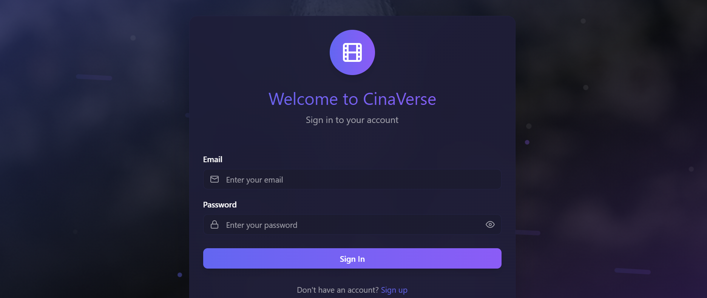



Figure 1 - signin page

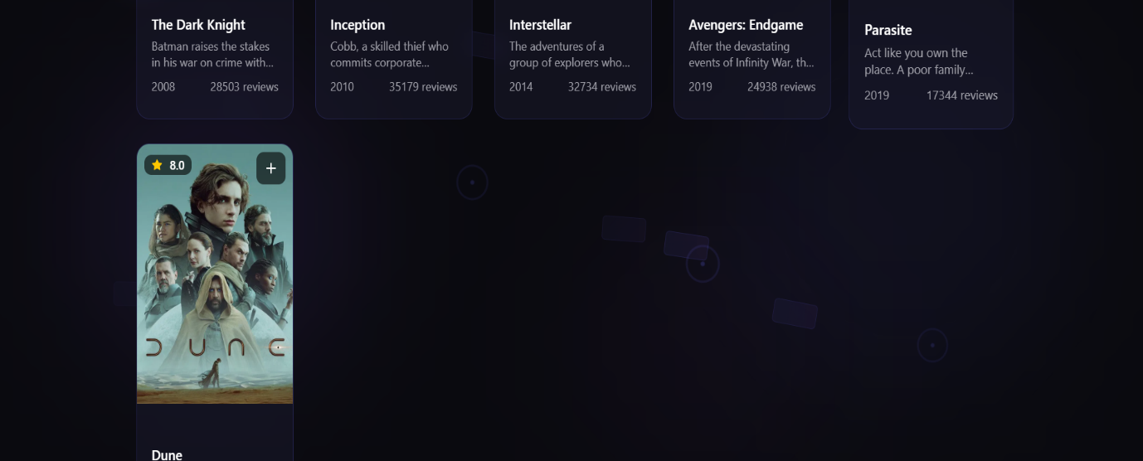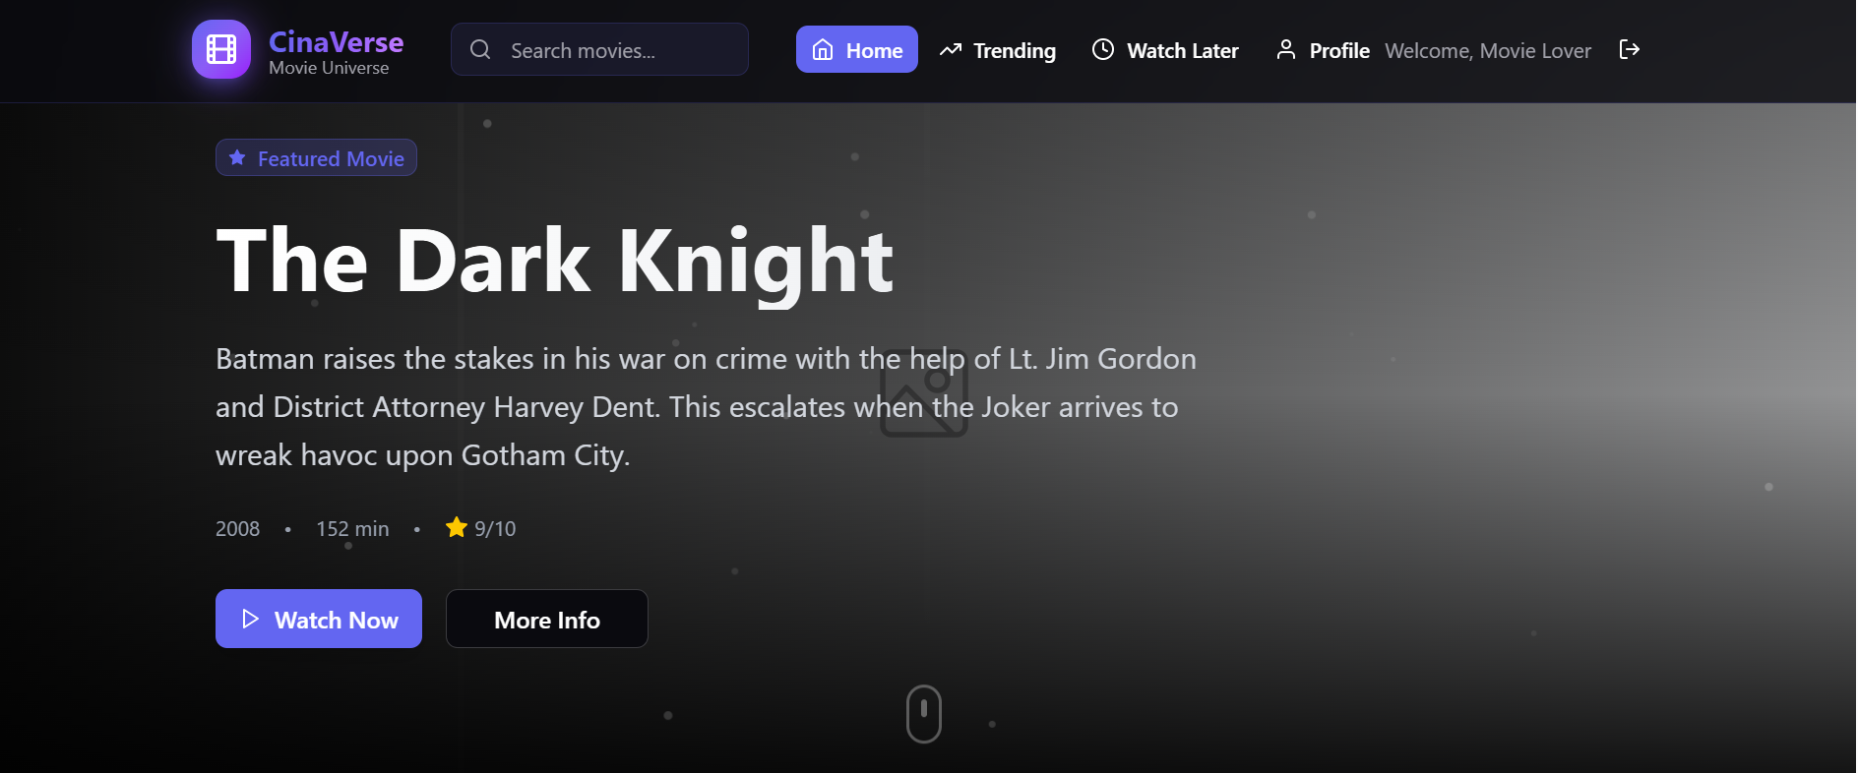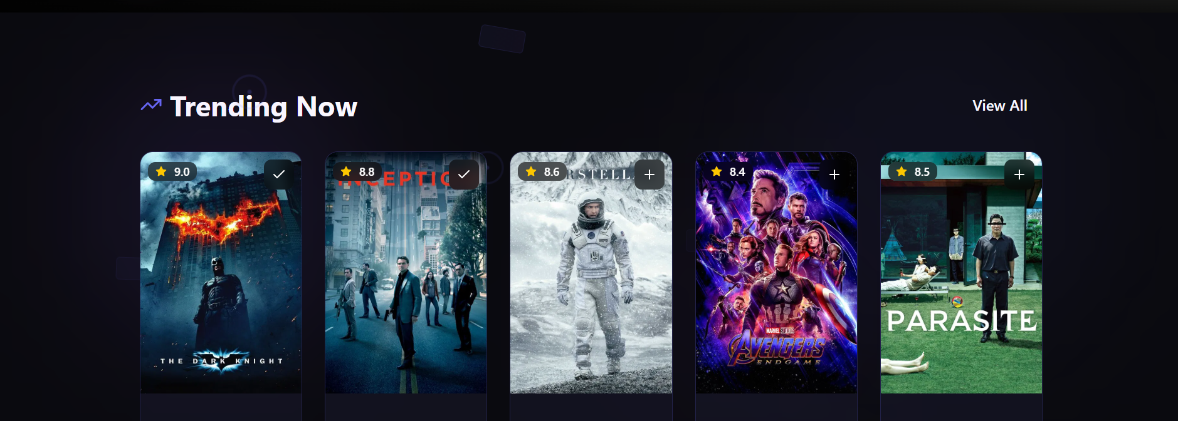

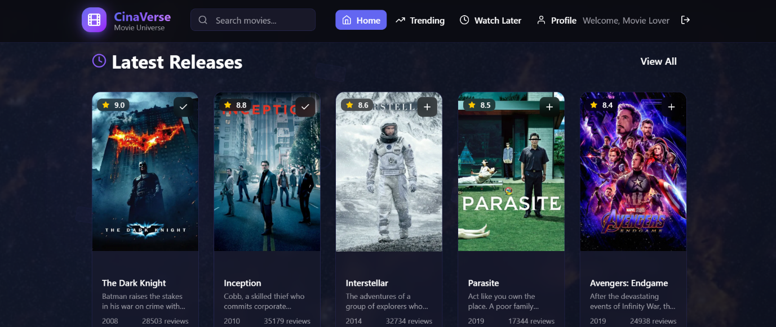

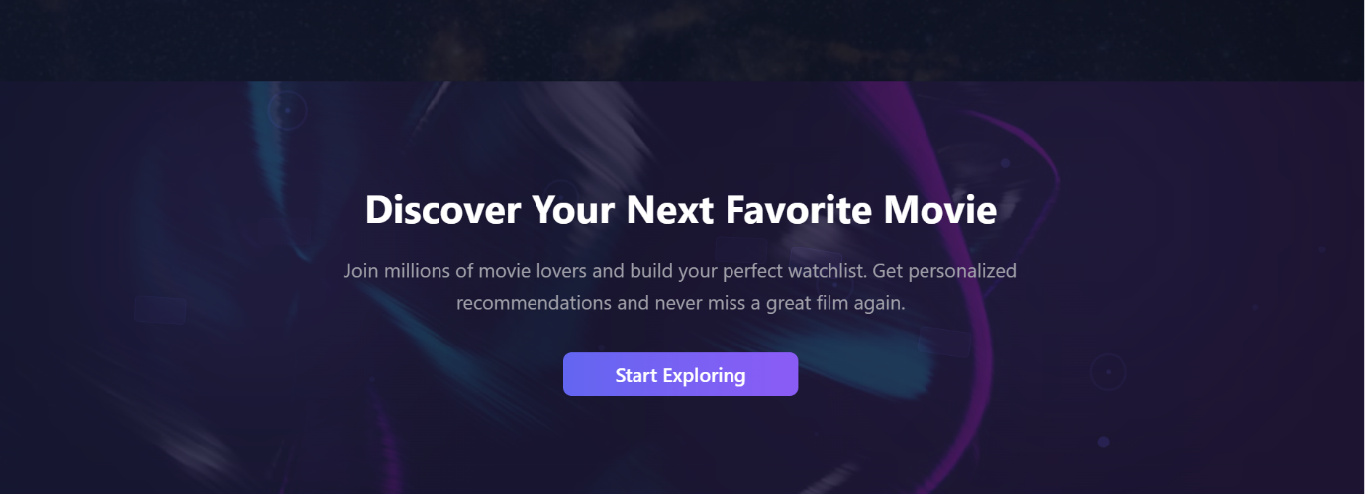

Figure 2 - Homepage

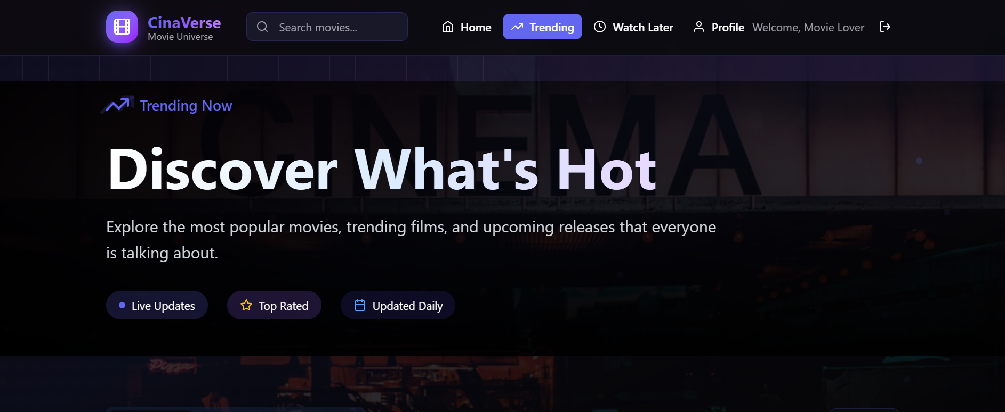

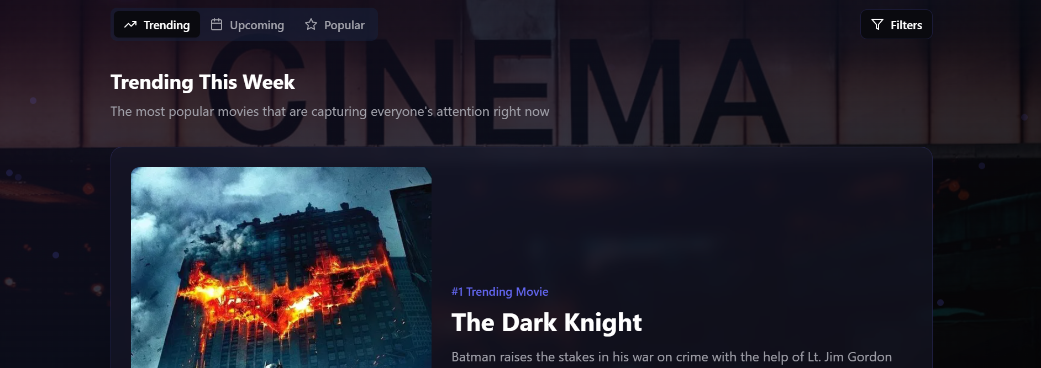

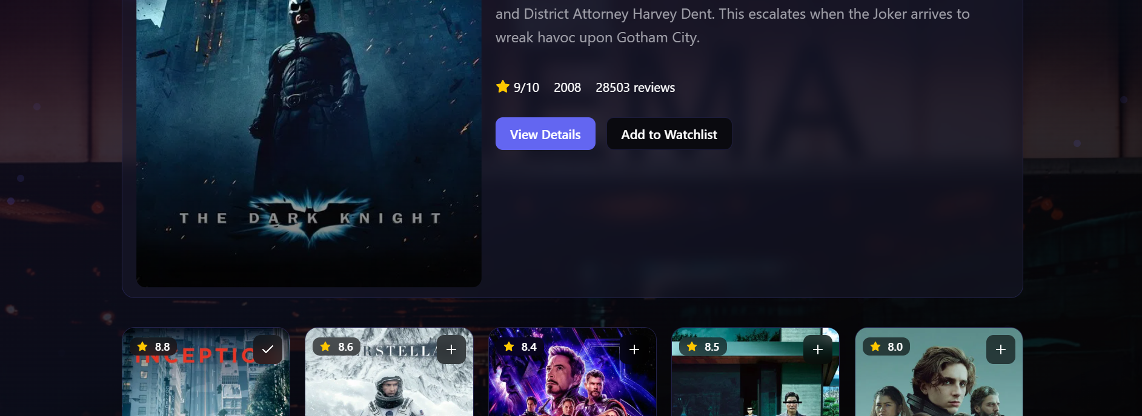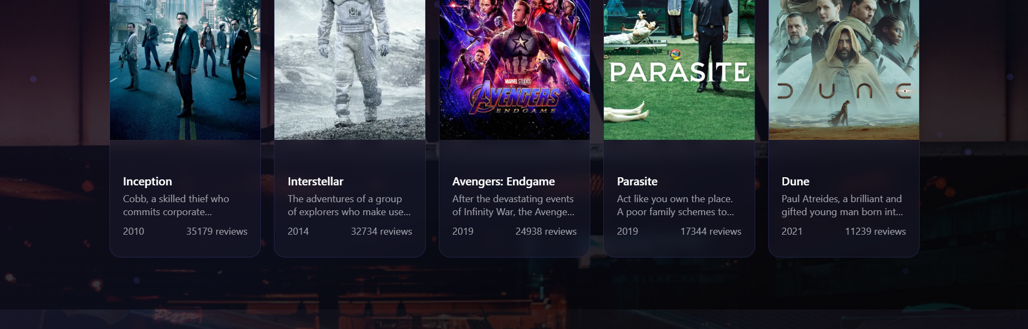

Figure 3 - Trending page

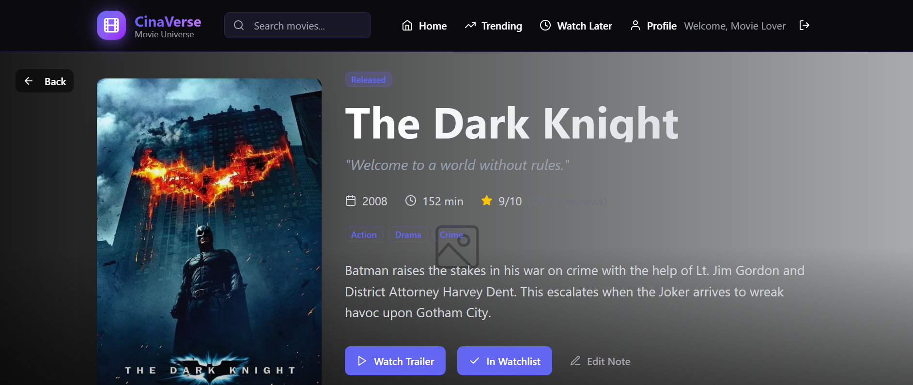

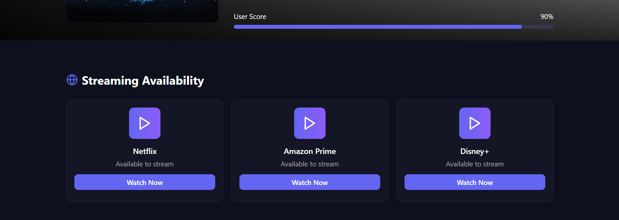

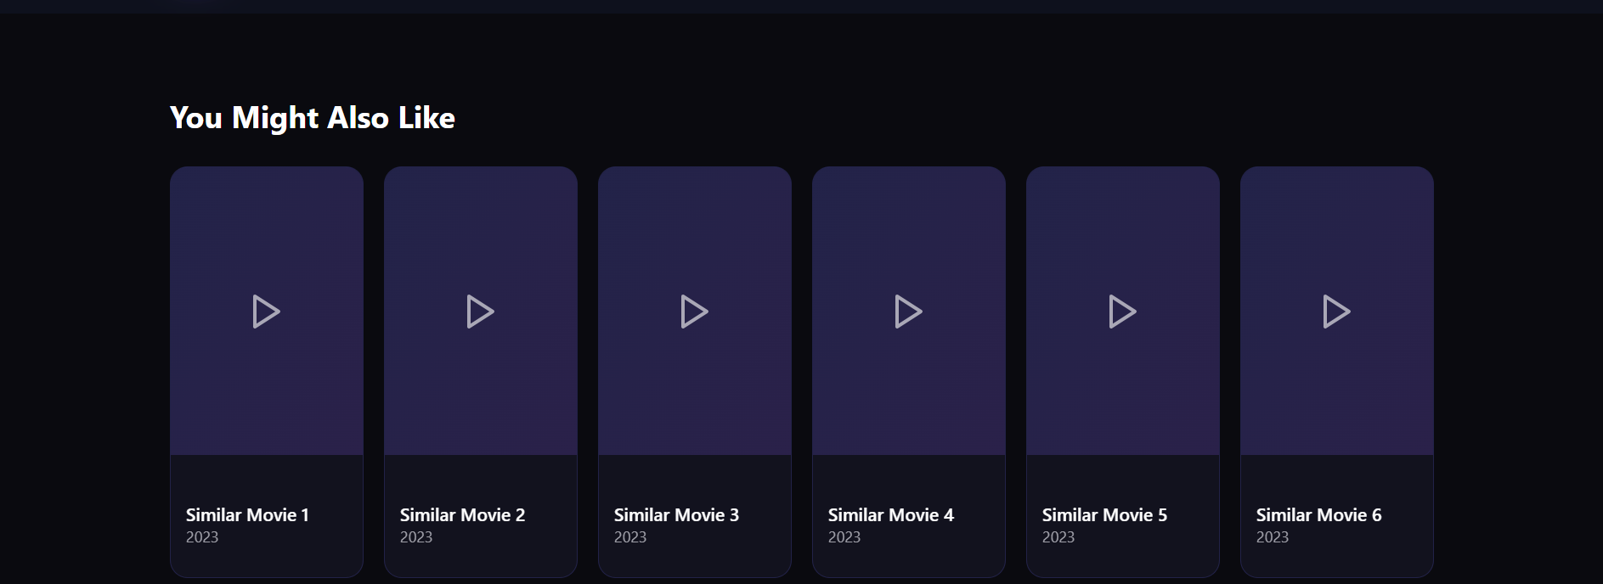

Figure 4 - Movie details page

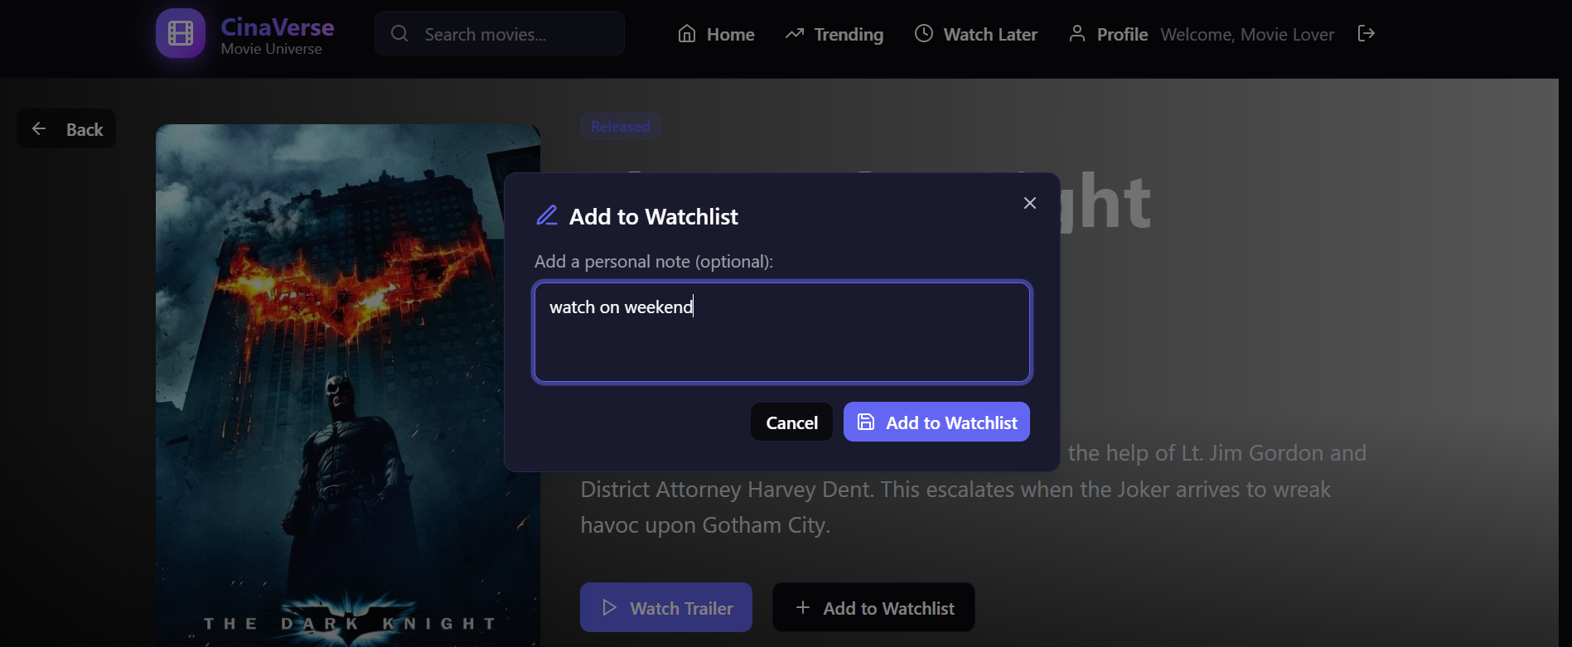

Figure 5 - Additional note option while adding in watchlist

t

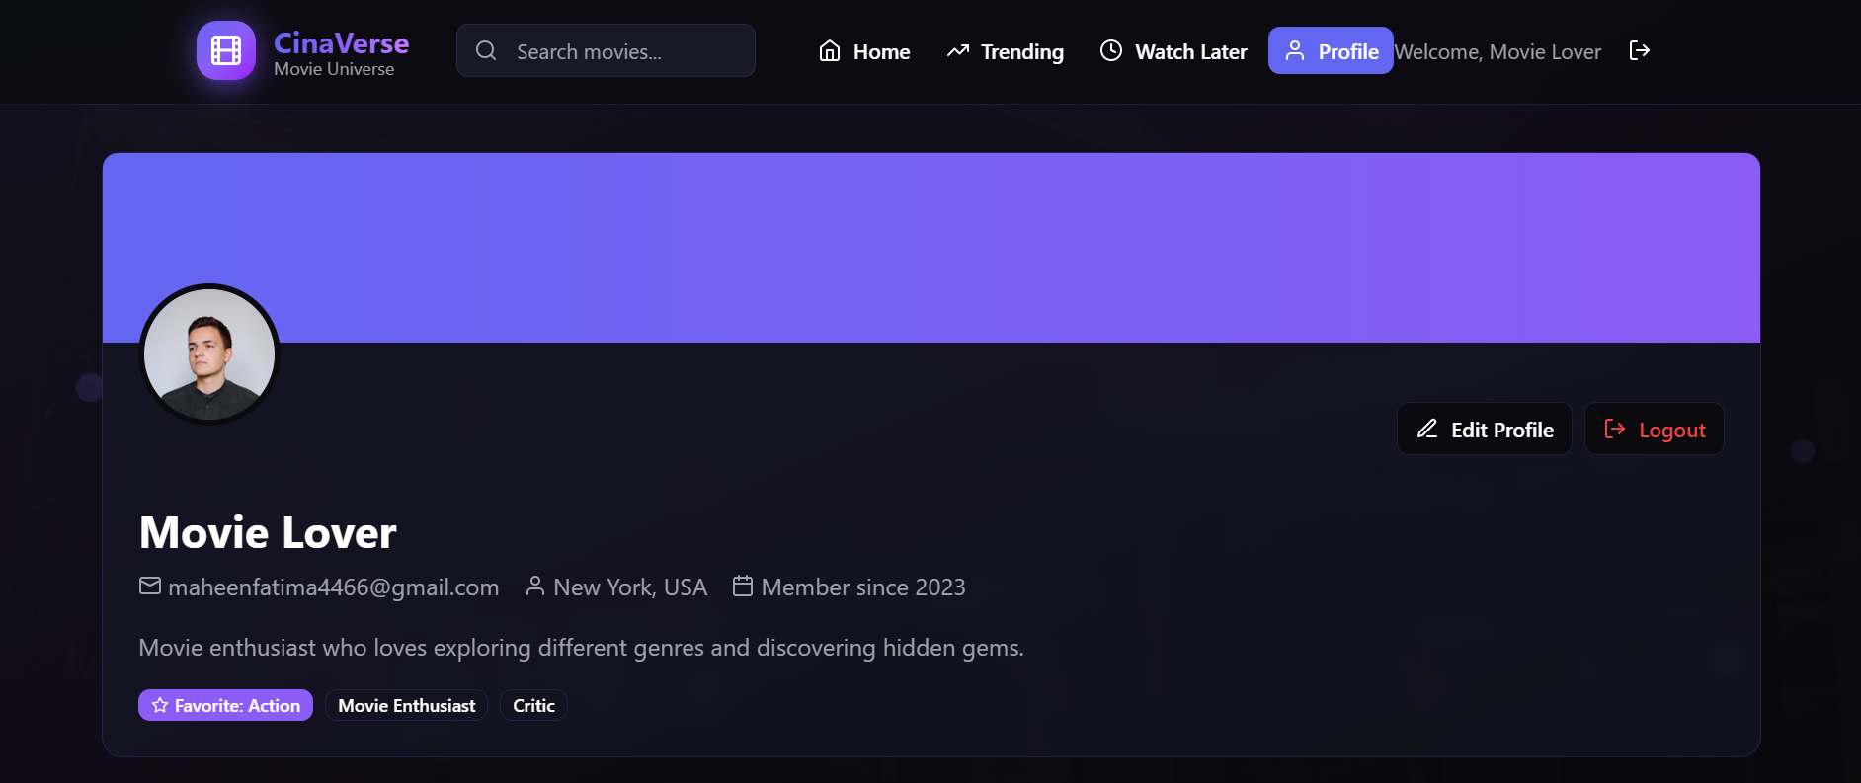

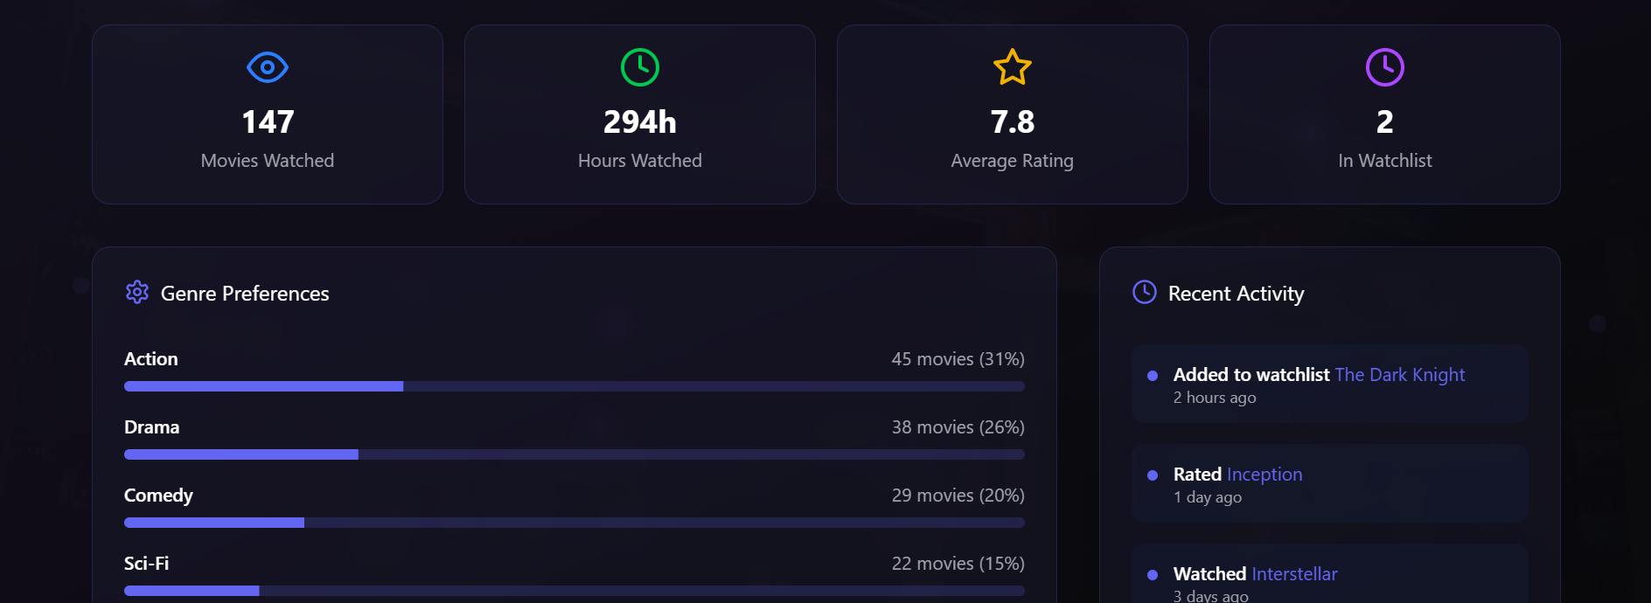

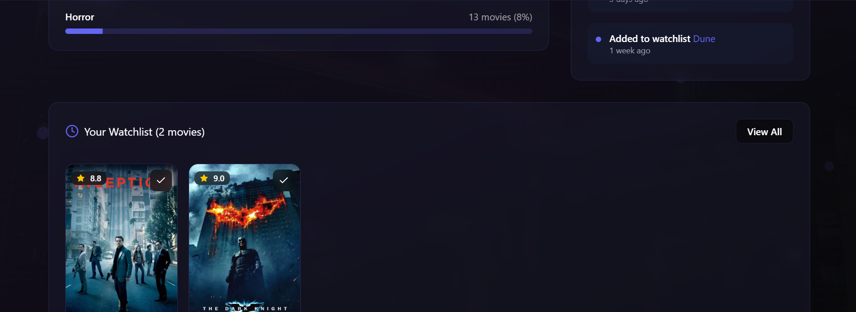

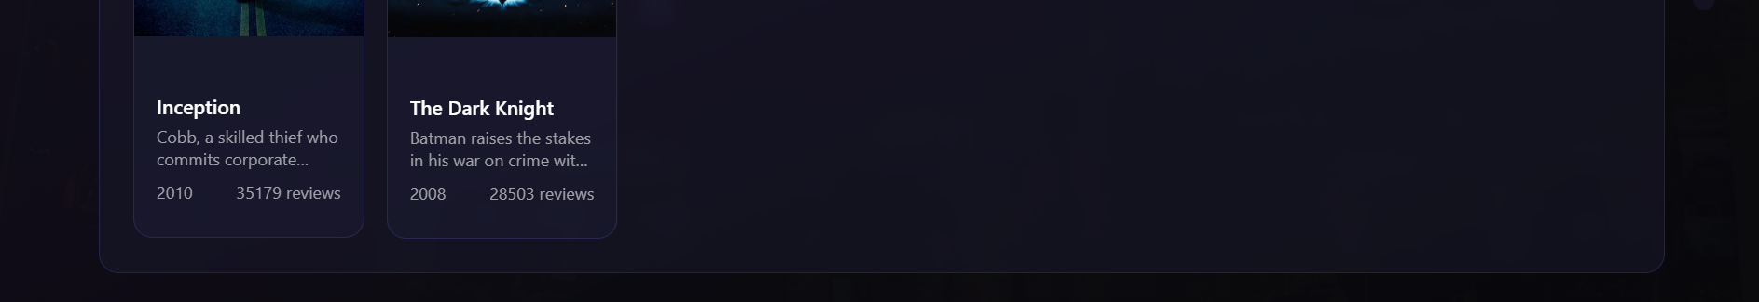

Figure 6 - User profilepage

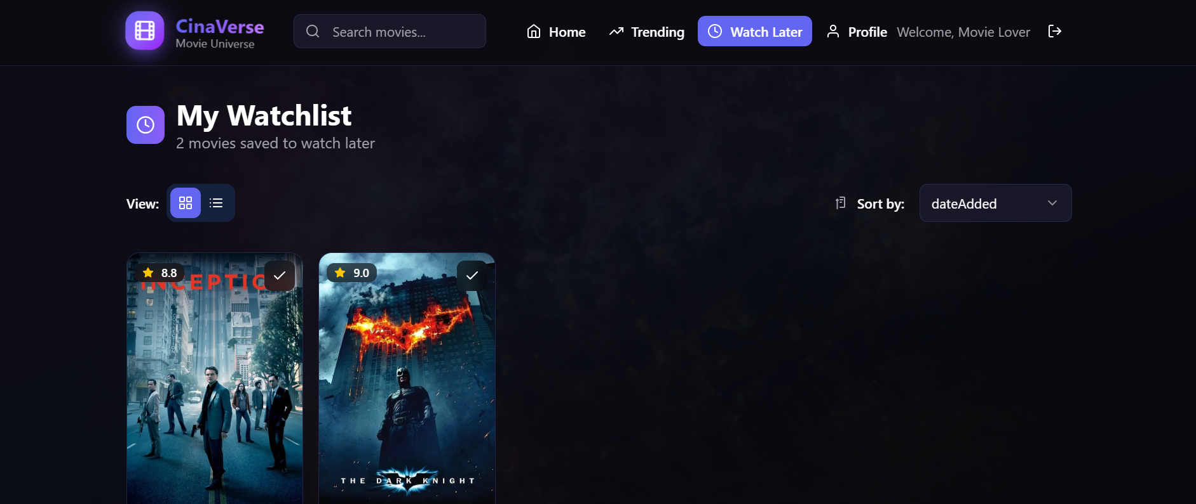

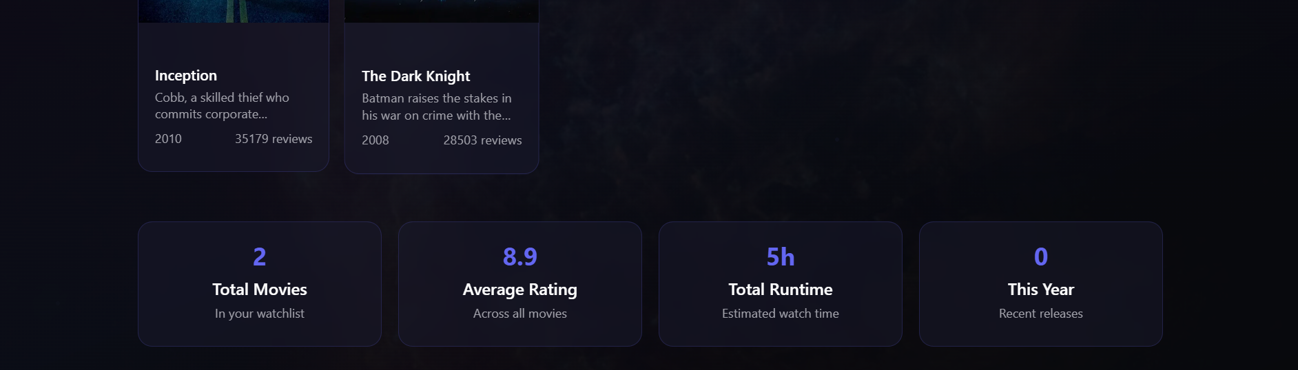

Figure 7 - Watchlist page

**Design 02:**

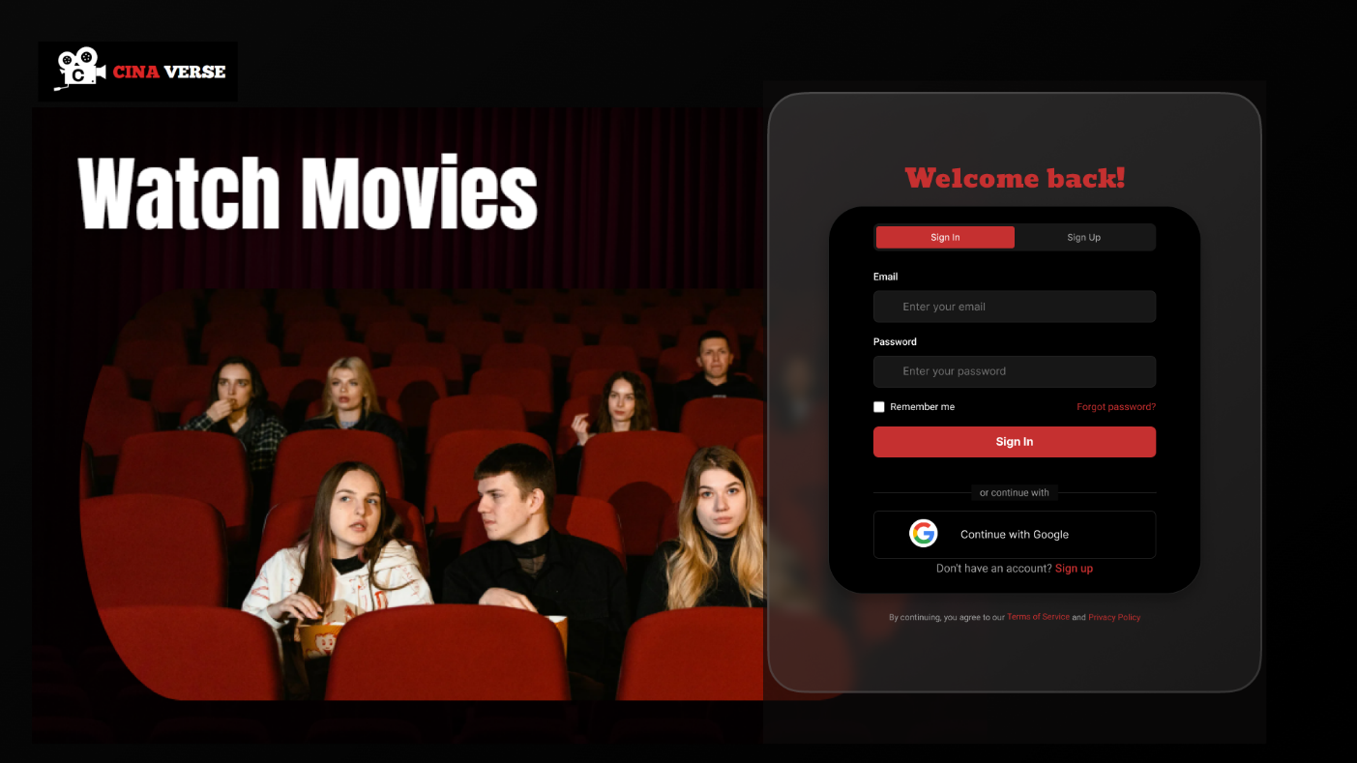

Figure 6 - Signup / Signin Page

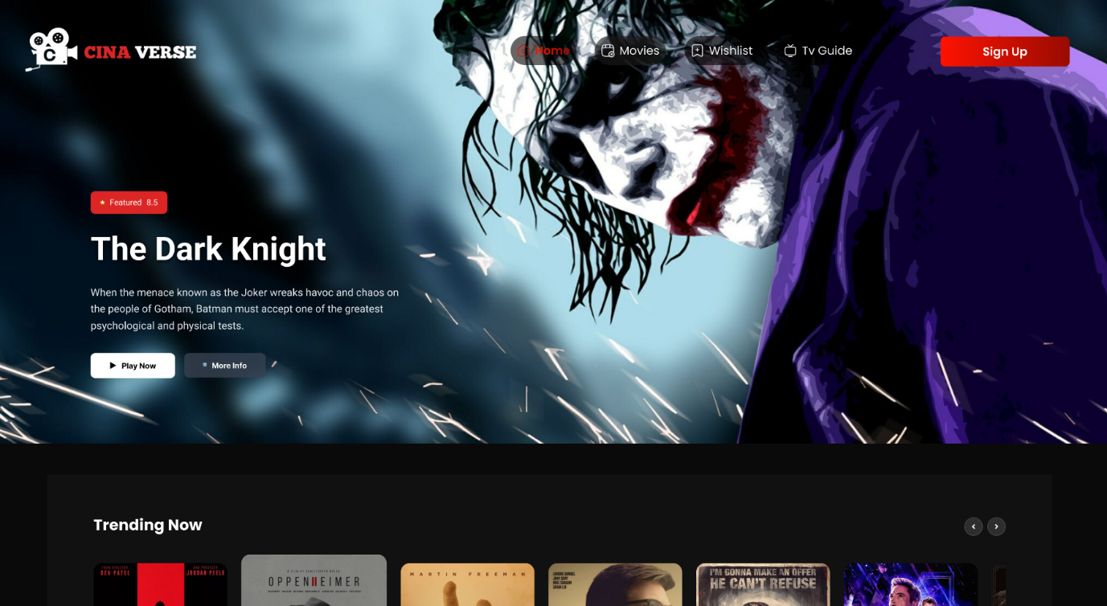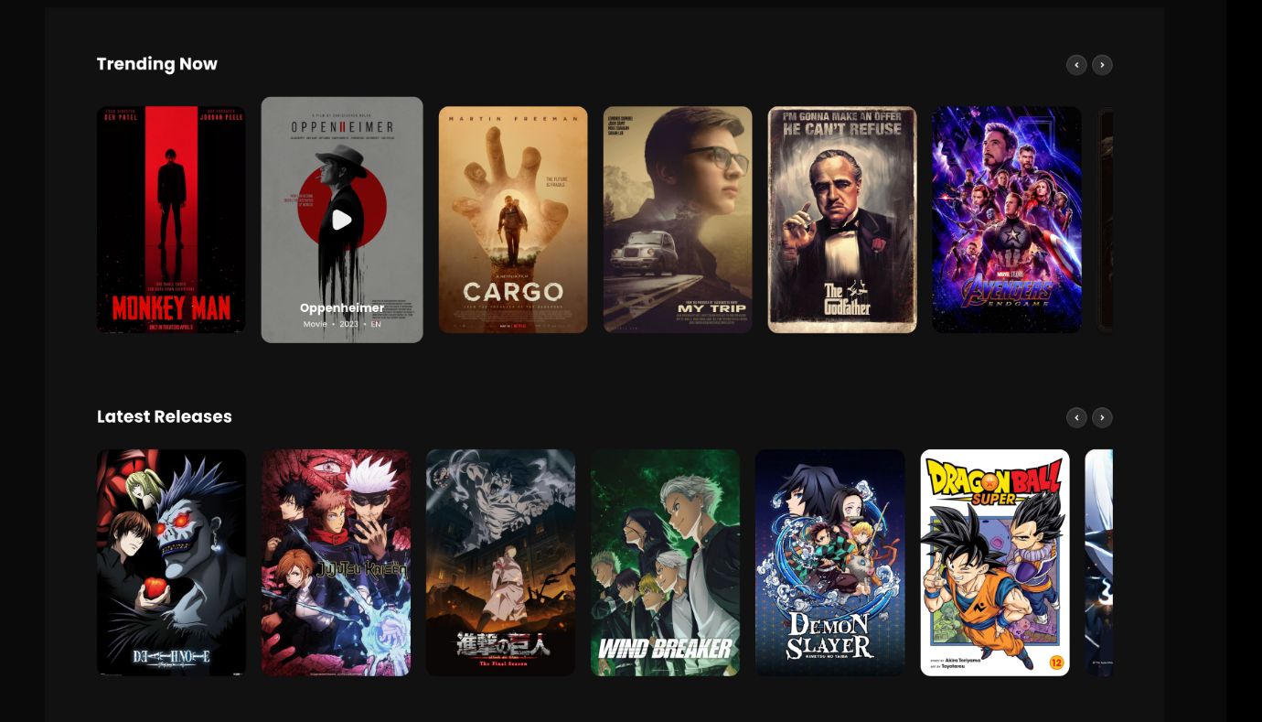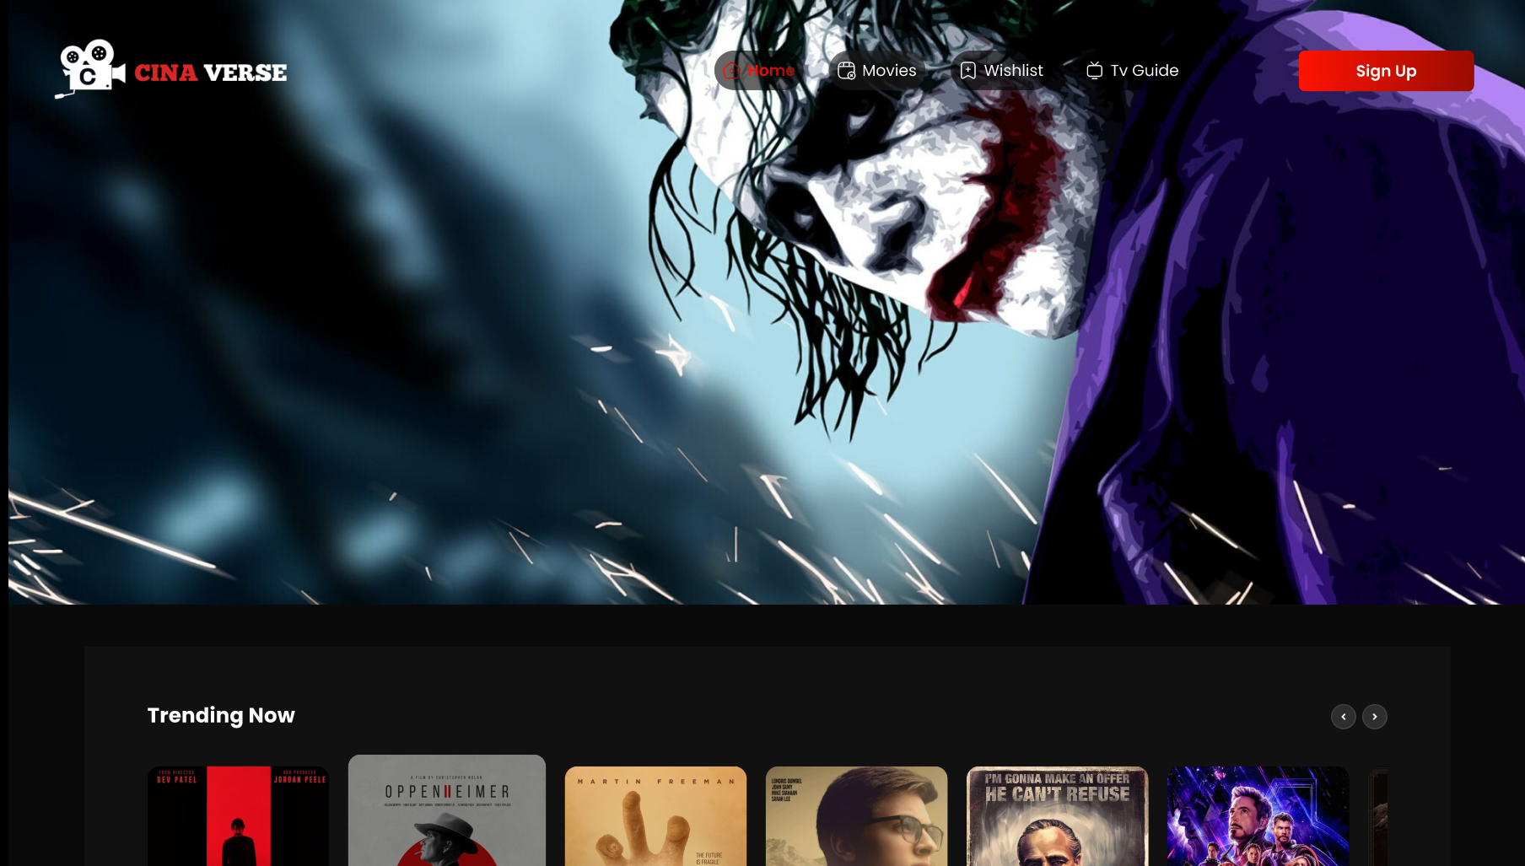

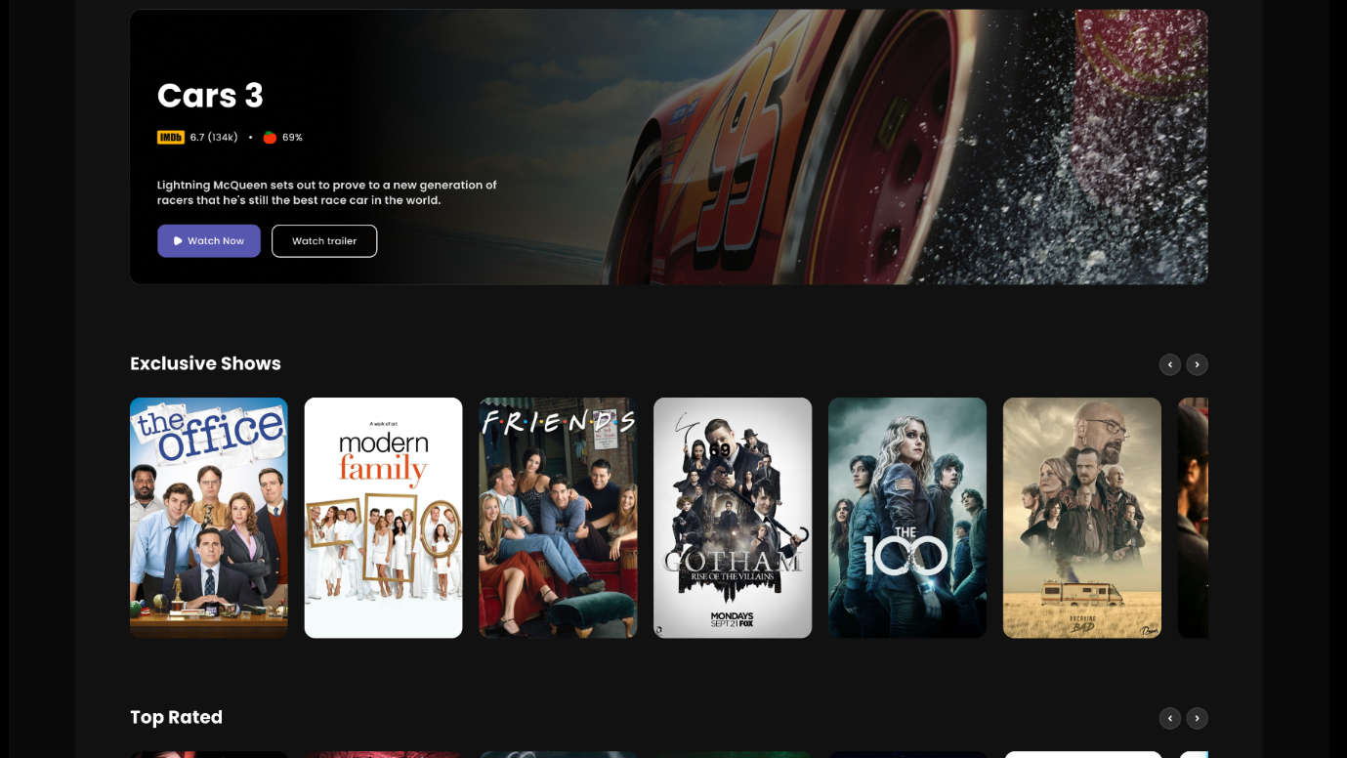

Figure 7 - HomePage(1)

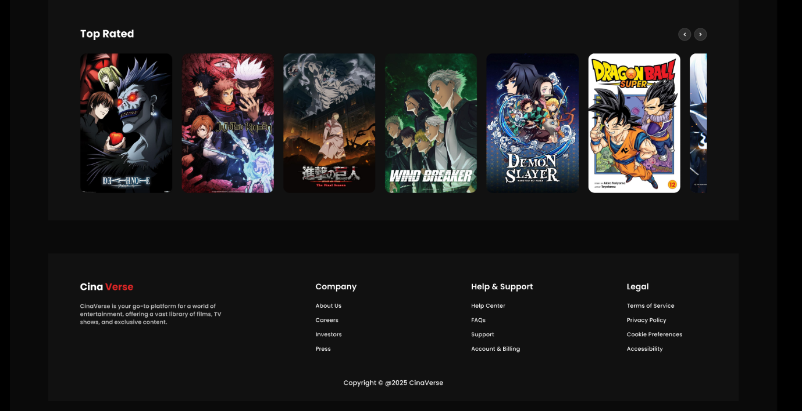

Figure 8 - HomePage(2)

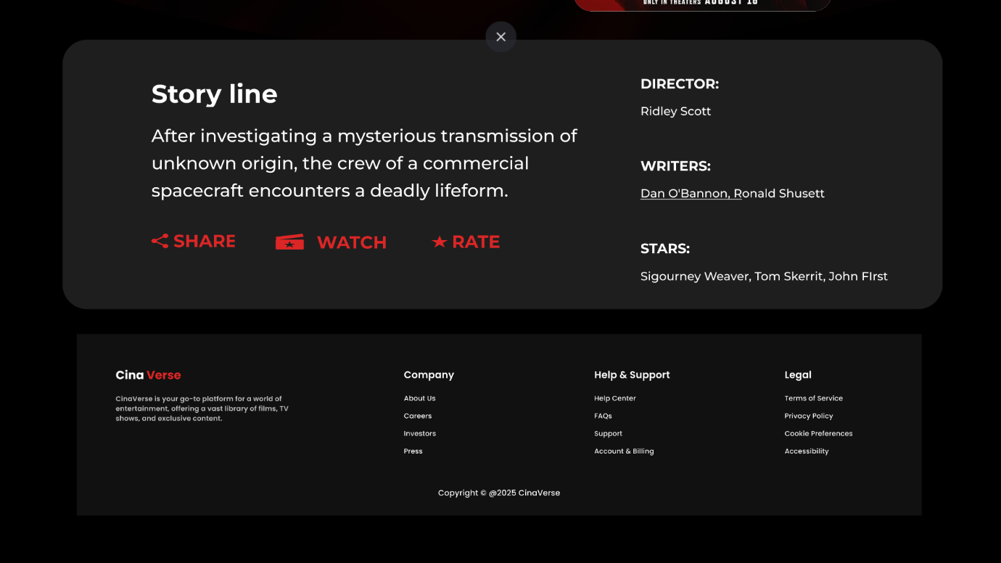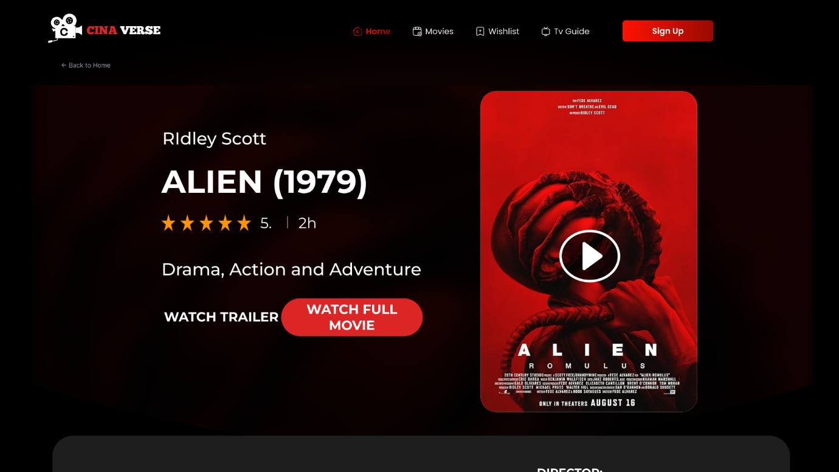

Figure 9 - MovieStreaming page

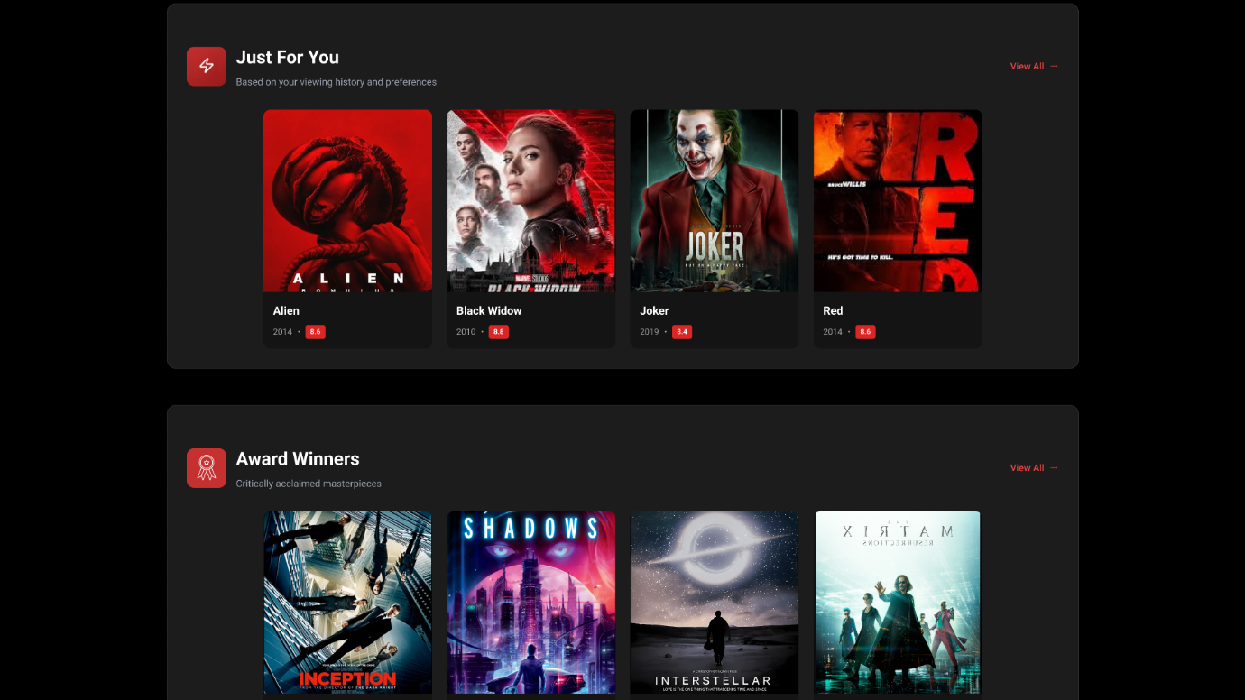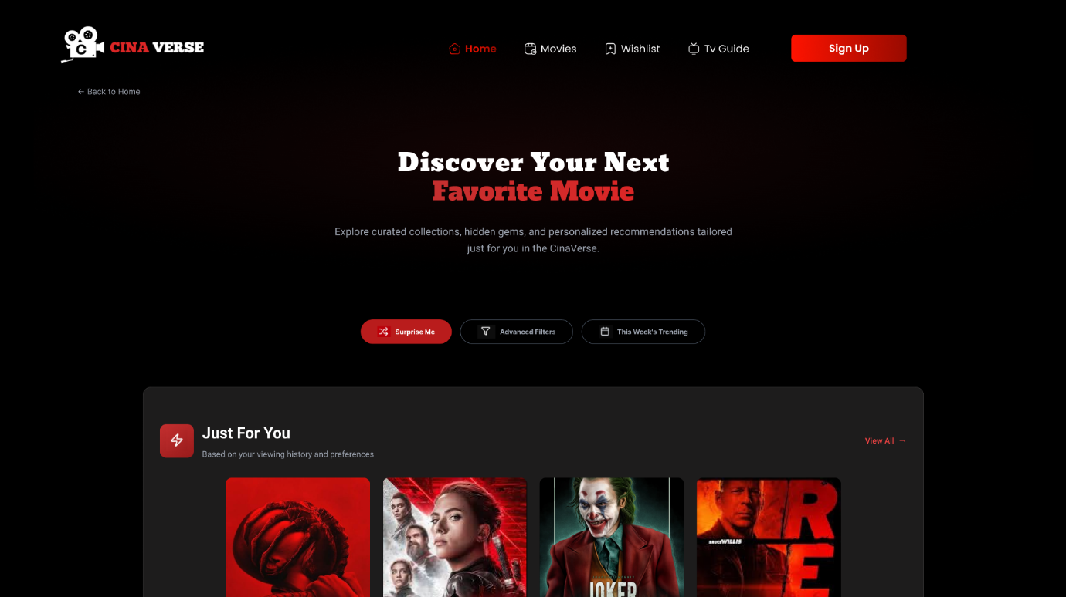

Figure 10 - DiscoverPage(2)

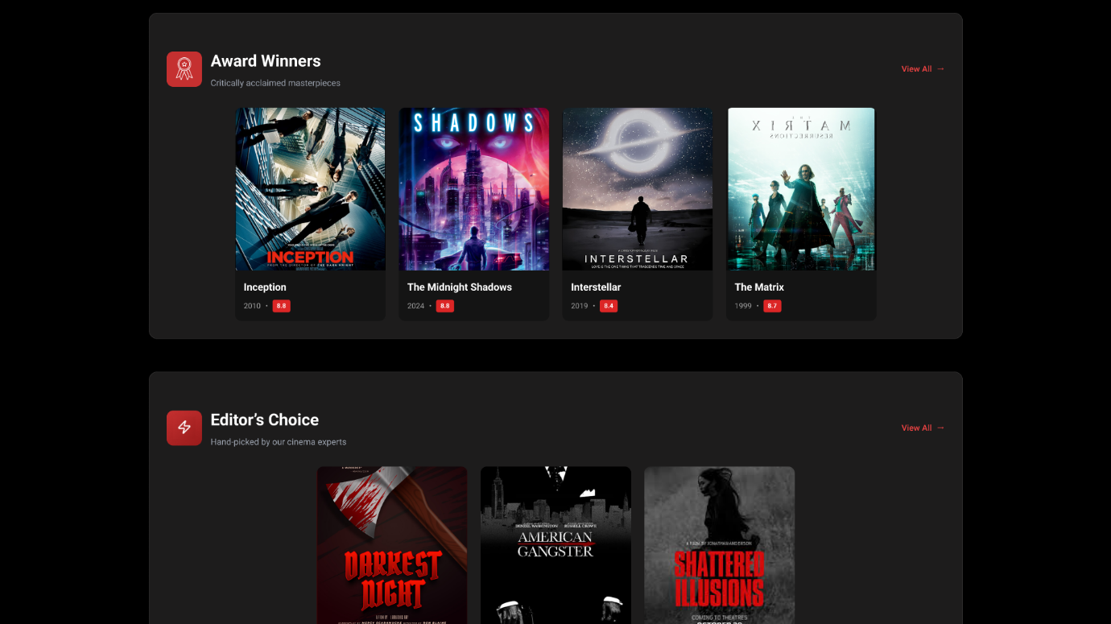

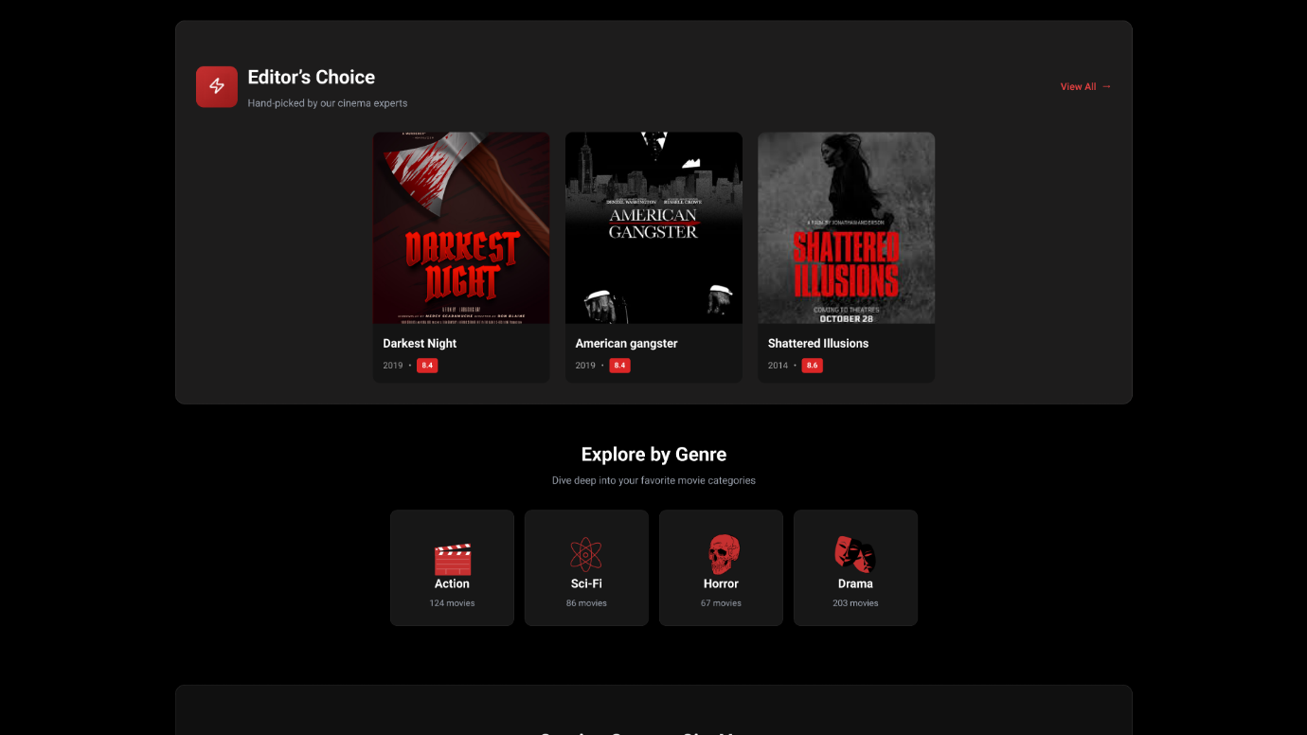

Figure 11 - DiscoverPage (1)

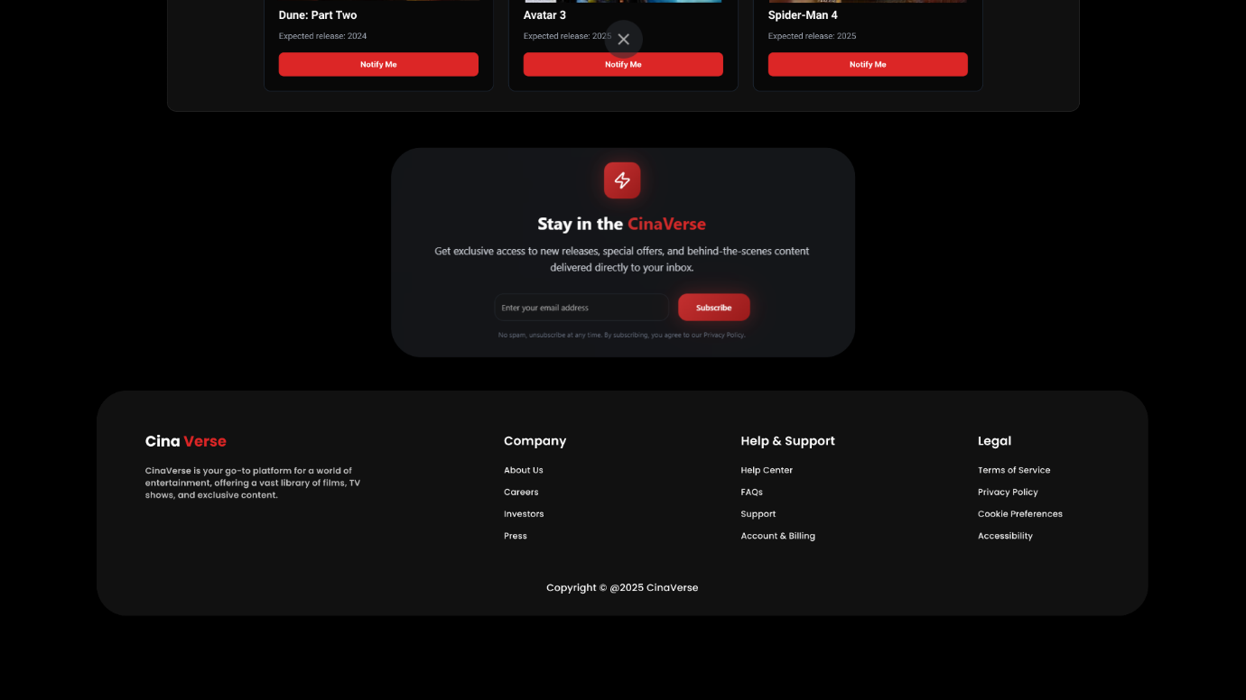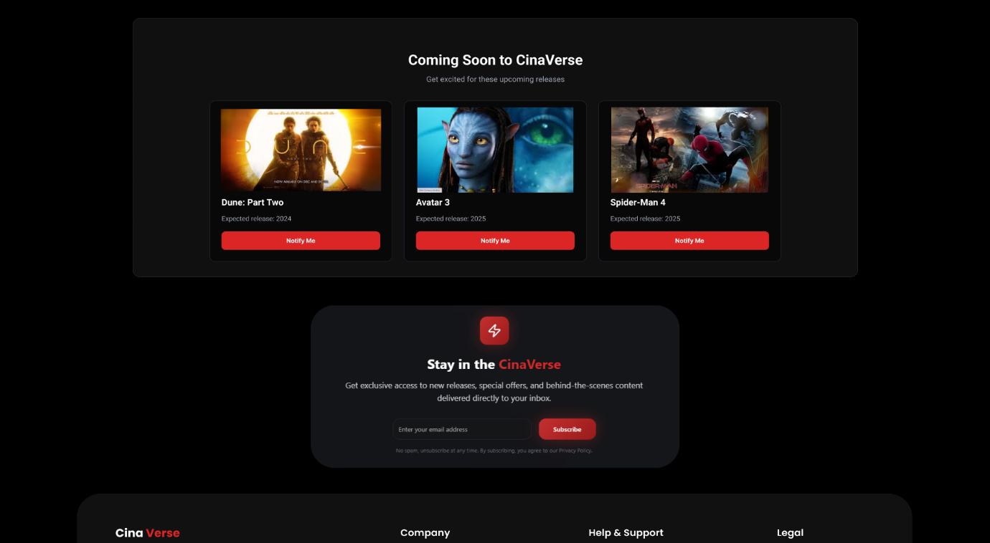

Figure 12 - DiscoverPage(2)

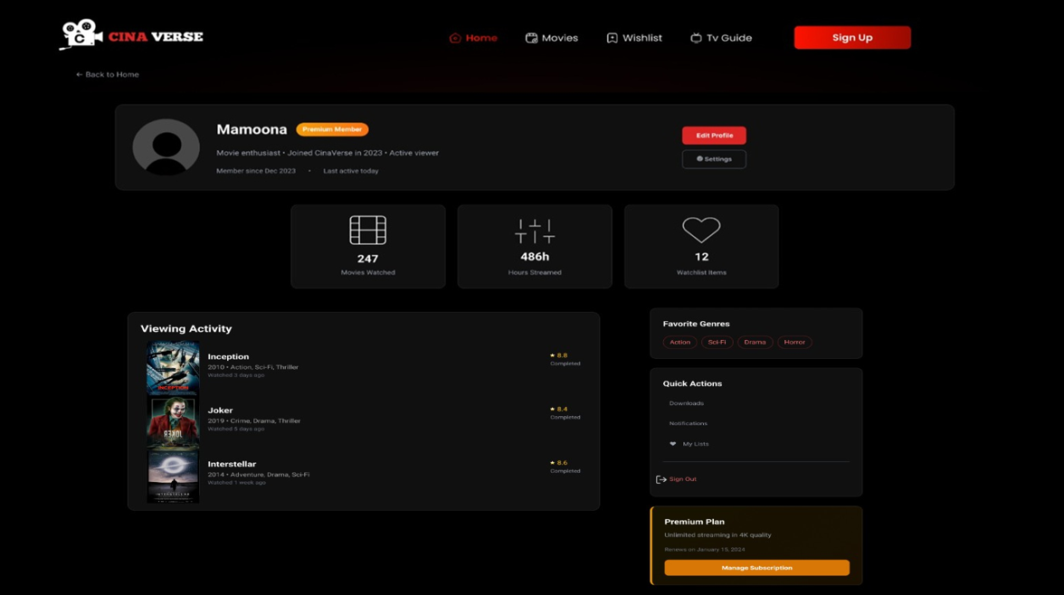

Figure 13 - Profile Page

# Conclusion

CinaVerse addresses a clear gap in the digital entertainment space by providing a centralized movie watchlist platform that combines movie search, details, streaming availability, and personalized management into one solution. By integrating the TMDb API, implementing secure authentication, and offering a modern, responsive UI, this project goes beyond a simple CRUD application.

The development process not only enhances our technical skills in full-stack development (Node.js, Express, React/Vue, PostgreSQL/SQLite) but also exposes us to real-world challenges such as API integration, authentication, and deployment. With a structured sprint plan, CinaVerse is both feasible within the semester and provides significant learning value for the team.

This project will serve as a practical demonstration of how full-stack applications are designed, built, and deployed in real-world scenarios while delivering a user-friendly and impactful solution for movie lovers.